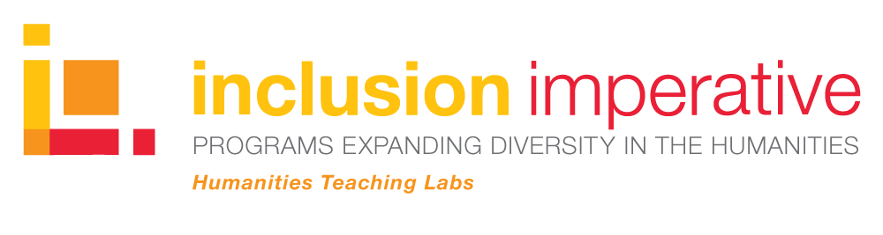
The Frederick Douglass Day Transcribe-a-thon is the first Humanities Teaching Lab (HT Lab) of the Dresher Center’s new Inclusion Imperative Program, funded by The Andrew W. Mellon Foundation. The Freedmen’s Bureau Transcription Project is presented by the Smithsonian National Museum of African American History and Culture, the Smithsonian Transcription Center, and the Colored Conventions Project.

RESOURCES:

Recent digital crowdsourcing projects to explore and try:

- Beyond Words - This project from the Library of Congress’s LC Labs is an experiment in crowdsourcing and community engagement, with the goal of gathering more structured and usable metadata about the illustrations, comics, cartoons, and photographs in the Library's Chronicling America digital collection. The project allows site visitors to explore historical newspaper coverage of World War I and contribute to Library of Congress collections at the same time.
http://beyondwords.labs.loc.gov/#/

- Transcribe Bentham - This initiative, which launched in 2010 and is based in the Bentham Project at University College London, aims to engage the public in the online transcription of original and unstudied manuscript papers written by philosopher and reformer Jeremy Bentham (1748-1832).
http://www.ucl.ac.uk/transcribe-bentham

- Dear Professor Einstein: The Emergency Committee of Atomic Scientists in Post-War America - Albert Einstein’s personal Emergency Committee of Atomic Scientists files have been digitized by Oregon State University. Using the Omeka tool, digitized letters and metadata were included in an online exhibit. The Omeka plugin Scripto enables crowdscourced transcription of the letters.
http://scarc.library.oregonstate.edu/omeka/exhibits/show/ecas/the-fear/fear-main

- Citizen Archivist - Volunteers can help to transcribe and make digital collections of the U.S. National Archives and Records Administration more publicly accessible.
https://www.archives.gov/citizen-archivist

- What’s on the Menu? - The New York Public Library invites site visitors to transcribe historical restaurant menus that are in its collections.
http://menus.nypl.org

- Building Inspector - A digital tool was used by The New York Public Library to extract, correct, and analyze data from historical maps originally commissioned by insurance companies to assess property value and fire risk. These maps feature long-destroyed buildings, streets that have been renamed, or whole neighborhoods that have since been redrawn. The goal is to produce a comprehensive directory of old New York.
https://buildinginspector.nypl.org/

- Anti-Slavery Manuscripts - The Boston Public Library's Anti-Slavery collection—one of the largest and most important collections of abolitionist material in the United States—contains roughly 40,000 pieces of correspondence, broadsides, newspapers, pamphlets, books, and memorabilia from the 1830s through the 1870s. Site visitors are invited to help to turn this collection of handwritten correspondence between anti-slavery activists in the 19th century into texts that can be more easily read and researched by students, teachers, historians, and big data applications.
https://www.antislaverymanuscripts.org/

- The Civil War in Letters - The Newberry Transcription Project uses Civil War soldiers’ letters held in the Modern Manuscript Collection of Chicago’s Newberry Library to understand the history of the American Civil War. Site visitors can aid research and enrich the historical record by transcribing these handwritten letters and reviewing the work of other transcribers.
http://publications.newberry.org/civilwarletters/

- Making History: Transcribe - Transcribe is the Library of Virginia’s collaborative online workspace where the public can participate in enhancing access to their collections documenting over 400 years of Virginia history, people, and culture.
http://www.virginiamemory.com/transcribe/

- GeoTag-X - GeoTag-X is a project of the United Nations Institute for Training and Research’s Operational Satellite Applications Programme (UNITAR-UNOSAT). Their aim to help disaster relief efforts on the ground to plan a response by asking volunteers to analyze photos taken in disaster-affected areas.
https://geotagx.org/

- Mapping Emotions in Victorian London - The project invites volunteers to annotate passages drawn from novels, published mainly in the Victorian era, that represented London places in a fearful, happy, or unemotional manner. This data from the crowd allowed the Stanford Literary Lab at Stanford University to generate the maps you find here, revealing a previously unseen emotional geography of Victorian London.
https://www.historypin.org/en/victorian-london/

- Book Traces - Book Traces at the University of Virginia is a large-scale project to find and record historical readers’ interventions. Readers wrote in their books, and left pictures, letters, flowers, locks of hair, and other things between the pages in the circulating collections of the University of Virginia Library (those published before 1923). Site visitors are asked to help identify them, since many are in danger of being discarded as libraries go digital.

- Transcribing Mixtec - This digital initiative by the Archive of the Indigenous Languages of Latin America at the University of Texas Austin asks volunteers to help transcribe handwritten scientific transcriptions of indigenous Latin American languages.
http://crowdcrafting.org/project/transcribingmixtec/

- Operation War Diary - This joint venture by the British National Archives, the Imperial War Museums, and Zooniverse lets site visitors tag and categorize information in the war diaries of British and Indian troops during World War I.
https://www.operationwardiary.org/

- Mapping the Fourth of July - This project from Virginia Tech uses crowdsourcing to transcribe and tag primary sources showing how Americans celebrated the Fourth of July from the 1840s to the 1870s.
http://july4.civilwar.vt.edu/

Several notable crowdsourced digital archives:

- Preserve the Baltimore Uprising - This digital repository project was developed by UMBC Associate Professor of History Denise Meringolo and Joe Tropea, Maryland Historical Society digital projects specialist, with help from student interns. The project, which is hosted by the Maryland Historical Society, seeks to preserve and make accessible original content that was captured and created by community members, grassroots organizations, and witnesses to the protests that followed the death of Freddie Gray on April 19, 2015.
https://www.baltimoreuprising2015.org/

- Our Marathon - This crowd-sourced archive, hosted by Northeastern University, includes pictures, videos, stories, and social media related to the Boston Marathon, the bombing on April 15, 2013, the subsequent search, capture, and trial of the individuals who planted the bombs, and the city’s healing process.
http://marathon.neu.edu/

UMBC Digital Humanities community mapping project, developed with students:
- Mapping Baybrook - This interdisciplinary exploration of place uses digital mapping to illustrate research on the history and culture of an industrial community in Baltimore, Maryland. The story of Greater Baybrook reflects the tenacity of a community striving for sustainability in the boom and bust of U. S. industrial development. The public humanities project was developed by UMBC Associate Professor of American Studies Nicole King, Professor of Visual Arts Stephen Bradley, and the UMBC Imaging Research Center, along with UMBC students.

